**ASSIGNMENT REPORT**

**15MH301 – FUNDAMENTALS OF ROBOTICS ASSIGNMENT 2 (AY 2019-2020, ODD)**

SUBMITTED BY

**NAME:** CHINMAY VILAS SAMAK

**REGISTER NUMBER:** RA1711018010102 **DATE OF SUBMISSION:** 21ST OCTOBER, 2019

**DUE DATE:** 21ST OCTOBER, 2019

**DEPARTMENT OF MECHATRONICS ENGINEERING SRM INSTITUTE OF SCIENCE AND TECHNOLOGY KATTANKULATHUR**

**FACULTY SIGNATURE**

EVALUATION /10

REMARKS:

(Ranjith Pillai R)

## INSTRUCTIONS

### Answer all questions

* The assignment report should be submitted in the format given.
* The assignment report should be submitted in hard copy only on or before due date
* Date of Submission/presentation will not be changed
* It’s the effort and learning that matters!!! Do your best!!!
* DO NOT COPY.

**TOTAL QUESTIONS: 2 NUMBERS ANSWER ALL THE QUESTIONS**

**QUESTION 1:**

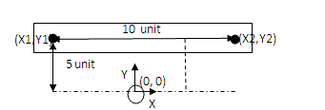

A 2R planar manipulator is placed at the point O at the origin where the frame is assigned. Task is to take an object from (X1, Y1) and place it at (X2, Y2). The manipulator description is given, find the following

* 1. Find the cartesian points (X1, Y1) and (X2, Y2) w.r.t the origin
  2. Find the joint angles (theta1 and theta2) of the robot for the Cartesian points (X1, Y1) and (X2, Y2)

(Hint: Use the inverse kinematic equation for planar 2R planar arm solved in the class)

* 1. Fit the points (X1, Y1) and (X2, Y2) with joint space cubic polynomial trajectory planner
  2. Use the coordinated scheme for the motion. Find the total time for the trajectory and velocity of each joint for the motion
  3. Fill the table given below

|  |  |  |  |  |  |  |  |  |  |  |  |
| --- | --- | --- | --- | --- | --- | --- | --- | --- | --- | --- | --- |
| **Time** | 0s | 0.09409s | 0.18818s | 0.28227s | 0.37636s | 0.47045s | 0.56454s | 0.65863s | 0.75272s | 0.84681s | 0.9409s |
| **Theta 1** | $$59.28°$$ | $$56.645°$$ | $$49.494°$$ | $$38.957°$$ | $$26.16°$$ | $$12.235°$$ | $$-1.69°$$ | $$-14.486°$$ | $$-25.024°$$ | $$-32.175°$$ | $$-34.81°$$ |
| **Theta 2** | $$159.636°$$ | $$159.636°$$ | $$159.636°$$ | $$159.636°$$ | $$159.636°$$ | $$159.636°$$ | $$159.636°$$ | $$159.636°$$ | $$159.636°$$ | $$159.636°$$ | $$159.636°$$ |
| **Joint 1 Velocity** | $100°/s$ | | | | | | | | | | |
| **Joint 2 Velocity** |  | | | | | | | | | | |

|  |  |
| --- | --- |
| 2R Planar Arm Specifications | |
| Length of Link 1 | 20 units |
| Length of Link 2 | 20 units |
| Joint Motor Velocity (Maximum) | 100 deg/sec |

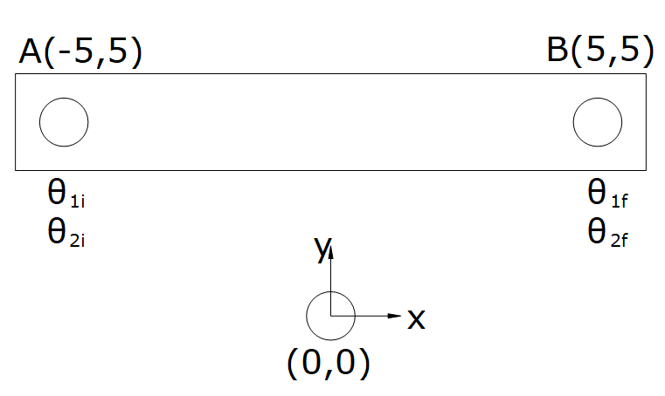

**IK Model of 2R Planar Robot:**

$$θ_{2}=\cos^{-1}\left[\frac{x^{2}+y^{2}-{L_{1}}^{2}-{L_{2}}^{2}}{2L_{1}L_{2}}\right]$$

$$θ_{1}=\tan^{-1}\left[\frac{y(L_{1}+L_{2}\cos{θ_{2})-x(L_{2}\sin{θ_{2})}}}{x(L_{1}+L_{2}\cos{θ_{2})+y(L_{2}\sin{θ_{2})}}}\right]$$

**IK At Point A (-5,5):**

$$θ_{2}=\cos^{-1}\left[\frac{{\left(-5\right)}^{2}+5^{2}-{20}^{2}-{20}^{2}}{2*20*20}\right]$$

$${θ_{2}=cos}^{-1}\left[\frac{50-800}{800}\right]$$

$${θ_{2}=cos}^{-1}\left[-\frac{750}{800}\right]$$

$${θ_{2}=cos}^{-1}\left(-0.9375\right)$$

$$\boxed{∴θ_{2i}=159.636°}$$

$$θ_{1}=\tan^{-1}\left[\frac{5(20+20*\cos{159.636)-(-5)(20\sin{159.636)}}}{(-5)(20+20*\cos{159.636)+5(20\sin{159.636)}}}\right]$$

$$θ_{1}=\tan^{-1}\left[\frac{6.25+34.8}{-6.25+34.8}\right]$$

$$θ_{1}=\tan^{-1}\left[\frac{41.05}{28.55}\right]$$

$$θ_{1}=\tan^{-1}{(1.683)}$$

$$\boxed{∴θ_{1i}=59.28°}$$

**IK At Point B (5,5):**

$$θ_{2}=\cos^{-1}\left[\frac{5^{2}+5^{2}-{20}^{2}-{20}^{2}}{2*20*20}\right]$$

$${θ_{2}=cos}^{-1}\left[\frac{50-800}{800}\right]$$

$${θ_{2}=cos}^{-1}\left[-\frac{750}{800}\right]$$

$${θ_{2}=cos}^{-1}\left(-0.9375\right)$$

$$\boxed{∴θ_{2f}=159.636°}$$

$$θ_{1}=\tan^{-1}\left[\frac{5(20+20*\cos{159.636)-5(20\sin{159.636)}}}{5(20+20*\cos{159.636)+5(20\sin{159.636)}}}\right]$$

$$θ_{1}=\tan^{-1}\left[\frac{6.25-34.8}{6.25+34.8}\right]$$

$$θ_{1}=\tan^{-1}\left[\frac{-28.55}{41.05}\right]$$

$$θ_{1}=\tan^{-1}{(-0.695)}$$

$$\boxed{∴θ_{1f}=-34.81°}$$

**Joint Motion Required:**

$$\left|∆θ_{1}\right|=\left|-34.81-59.28\right|=94.09°$$

$$\left|∆θ_{2}\right|=\left|159.636-159.636\right|=0°$$

**Time Required for Joint Motion at Maximum Joint Velocity:**

$$t_{θ_{1}}=\frac{94.09}{100}=0.9409s$$

$$t_{θ_{2}}=\frac{0}{100}=0s$$

Hence, the time for coordinated motion is 0.9409 seconds.

**Joint Velocity:**

$\dot{θ_{1}}=\frac{94.09}{0.9409}=100°/s$ and $\dot{θ_{2}}=\frac{0}{0.9409}=0°/s$

**Joint Space Trajectory Planning (Cubic Polynomial):**

|  |  |
| --- | --- |
|  |  |
|  |  |

|  |  |
| --- | --- |
| A (-5,5) | B (5,5) |
| **Fig.** Initial Pose | **Fig.** Final Pose |

**QUESTION 2:**

Write your understanding about control law partitioning. Derive the Partition PD control equation for the system shown in figure and draw the closed loop control block diagram for the system.

(Hint: Refer class notes)

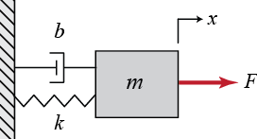

**Your understanding:**

Control partitioning is useful when designing controllers for complex systems (i.e. systems involving multiple system parameters).

According to this partitioning scheme, the controller is partitioned in the following two separate portions:

* Servo Portion
* Model-Based Portion

The servo portion acquires state feedback from the plant, computes the error w.r.t. desired setpoint and scales it with the respective controller gain to produce an output which can be suitably scaled and fed to the summing point, the other input of which is the output from model-based portion. The model-based portion, on the other hand, acquires state feedback from the plant, scales it with the respective system parameter(s) (which can be determined using system identification techniques) and generates an output (which is then added with the output of servo potion of the controller).

The combined output can be scaled based on requirement and fed to the plant as control input.

**Derivation for the system:**

**System Dynamics**

Applying Hooke’s law ($F=k*x$), the idealized friction law ($F=b*\dot{x}$) and Newton’s second law of motion ($F=m*\ddot{x}$) we obtain the dynamics of the given second order mass-spring-damper system as follows:

$$F=m\ddot{x}+b\dot{x}+kx$$

If we consider external undesired disturbance forces added to the system, then we obtain:

$$F=m\ddot{x}+b\dot{x}+kx+F_{d}$$

**Partition PD Control**

The control force is,

$$F_{c}=m\ddot{x}+b\dot{x}+kx+F_{d}$$

Partitioning the equation to isolate system parameters we get,

$$F_{c}=m\ddot{x}+(b\dot{x}+kx+F_{d})$$

The above equation can be re-written as,

$$F_{c}= αf'+β$$

Where $α$ corresponds to system constants (m in this case), $f'$ corresponds to control force independent of system parameters and $β$ corresponds to system variables/parameters (b, k in this case).

Thus, we can partition the controller into servo portion ($αf'$) and model-based portion ($β$).

|  |  |
| --- | --- |
| **Servo Portion** | **Model-Based Portion** |
| $$αf'=m\ddot{x}$$ Where $α=m$, $f'=\ddot{x}$ Applying PD control, $$f'=K_{p}e+K_{d}\dot{e}$$ Where $e= \ddot{x_{d}}-\ddot{x}$, $\dot{e}= \frac{de}{dt}$ | $$β=b\dot{x}+kx+F_{d}$$ Where b, k are system parameters which can be obtained analytically or by using system identification techniques.  The external disturbance or system noise $F_{d}$ can only be estimated using system identification techniques. |

**Closed Loop Control Block Diagram**

